Erich Viebrock

ECPE 178

Lab #2: Google Hacking

1. **Create a specific search for something, adding search operators to narrow the results. Show the search you used to get the most specific results.**

intitle:Home "display printer status" +.edu

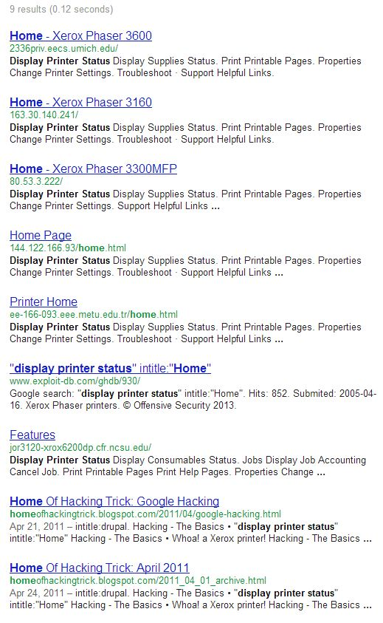

Note the 1st and 5th search results. The first is from the Electrical Engineering and Computer Science department of the University of Michigan, while the fifth is from the Electrical and Electronics Engineering department of the Middle East Technical University. Why is it the only non-IP URLs are from these departments, whereas printers from other departments are invisible, like the Art department?

1. **Google for yourself. Can you find any images of yourself? Any pages that list your address, phone, etc.? Any that you were not aware of?**

Yes, there are images of myself on Google. Here are the links I found that are my photos on some random website:

* <http://profile.ak.fbcdn.net/hprofile-ak-ash4/371289_1053060225_1442518323_q.jpg>
* <http://profile.ak.fbcdn.net/hprofile-ak-snc6/275737_1053060225_1684842918_q.jpg>

I don’t really mind those pictures being on Google. I assume they are cached versions of my old Facebook profile pictures, which are too small to even really distinguish what I really look like. There were other pictures linked to my name, but they weren’t of me. I also found it fairly easy to find my address, age, relatives, etc. I even found a website that had my location from co-op: Harrisburg, PA.

1. **There are at least two ways to keep Google for indexing content. What are they?**
2. Use robots.txt.
3. Use a noindex meta tag.
4. **What was the most interesting search you tried, and why?**

I found the search intitle:"not for distribution" confidential to be the most interesting and pool the largest sum of results. The very first result was from the West Virginia Department of Energy…surely something they don’t want to be retrievable! Below is a screenshot of the result:

